**Project Design Phase-II**

**Technology Stack (Architecture & Stack)**

|  |  |
| --- | --- |
| Date | 27 June 2025 |
| Team ID | LTVIP2025TMID35597 |
| Project Name | Pollen's Profiling: Automated Classification of Pollen Grains |
| Maximum Marks | 4 Marks |

**Technical Architecture:**

The technical architecture of Pollen's Profiling includes a web-based front-end (HTML, CSS, JS) for user interaction and a Flask-based Python back-end to handle image uploads and routing. A pre-trained CNN model processes the images for classification. The system stores images and predictions locally or in the cloud. It ensures modular, scalable, and secure integration of machine learning with web deployment.

The Deliverable shall include the architectural diagram as below and the information as per the table1 & table 2

Guidelines:

To build the **Pollen's Profiling** project, start by preparing a labeled dataset of pollen images and train a CNN model using TensorFlow or Keras. Use Flask to create a backend that loads the model and handles image uploads. Design a simple web interface (HTML/CSS/JS) for users to interact with the system. Finally, test and deploy the app locally or on a cloud platform like Heroku or Render

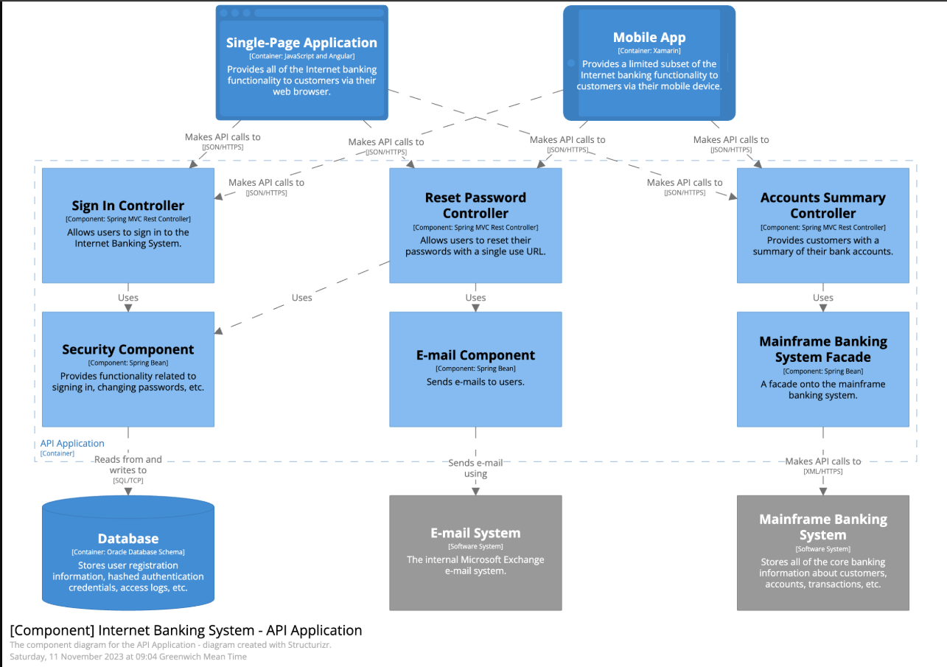

**Table-1 : Components & Technologies:**

|  |  |  |  |
| --- | --- | --- | --- |
| **S.No** | **Component** | **Description** | **Technology** |
|  | User Interface | How user interacts with application e.g.  Web UI, Mobile App, Chatbot etc. | HTML, CSS, JavaScript / Angular Js / React Js etc. |
|  | Application Logic-1 | Logic for a process in the application | Java / Python |
|  | Application Logic-2 | Logic for a process in the application | IBM Watson STT service |
|  | Application Logic-3 | Logic for a process in the application | IBM Watson Assistant |
|  | Database | Data Type, Configurations etc. | MySQL, NoSQL, etc. |
|  | Cloud Database | Database Service on Cloud | IBM DB2, IBM Cloudant etc. |
|  | File Storage | File storage requirements | IBM Block Storage or Other Storage Service or Local Filesystem |
|  | External API-1 | Purpose of External API used in the application | IBM Weather API, etc. |
|  | External API-2 | Purpose of External API used in the application | Aadhar API, etc. |
|  | Machine Learning Model | Purpose of Machine Learning Model | Object Recognition Model, etc. |
|  | Infrastructure (Server / Cloud) | Application Deployment on Local System / Cloud  Local Server Configuration:  Cloud Server Configuration : | Local, Cloud Foundry, Kubernetes, etc. |

**Table-2: Application Characteristics:**

| **S.No** | **Characteristics** | **Description** | **Technology** |
| --- | --- | --- | --- |
|  | Open-Source Frameworks | List the open-source frameworks used | Technology of Opensource framework |
|  | Security Implementations | List all the security / access controls implemented, use of firewalls etc. | e.g. SHA-256, Encryptions, IAM Controls, OWASP etc. |
|  | Scalable Architecture | Justify the scalability of architecture (3 – tier, Micro-services) | Technology used |
|  | Availability | Justify the availability of application (e.g. use of load balancers, distributed servers etc.) | Technology used |
|  | Performance | Design consideration for the performance of the application (number of requests per sec, use of Cache, use of CDN’s) etc. | Technology used |